Planning Ducument

Project Name: Gym Management of Facility, Memberships and Staff

Team Number: 2

Haocheng Sun 217174509

Tao Chen 216870297

Wenxu Ye 216870230

Zhige Xia 216665044  
Outline

**1. Vision Statement** **2**

**2. Big user stories** **3**

a. category 1: course enrollment 4

b. category 2: membership and coach management 5

c. category 3: facility management 6

## Vision Statement

General Functionality of the Project and Success Criteria

The project aims to create software that helps more people understand fitness classes, providing an online operating platform for all fitness enthusiasts. The target users are both gym memberships and the gym staff. The app should allow memberships to log in through the membership portal, while the gym staff will be given passwords and account names to log in as administrators for management purposes.

One goal of the project is to provide memberships information for courses they can take in the gym. Once they tap into a course, the course’s description, schedule, price, and general information about the coach shall be displayed. Once the course is successfully enrolled, the training schedule is automatically generated. Users can view their schedules at “My courses”. They can also add, remove or transfer a course. The project allows gym staff to modify the coach and memberships. The list of gym memberships and coaches can be visited on the main page. After clicking into a membership or coach, his or her basic information, funds, or salary remaining in the account, the course that’s currently taking should be presented. The gym staff can add a new membership or remove a current one. Also, the project enables gym staff to manage equipment. A list of equipment is shown on the main page. Gym staff can check the number of equipment the gym currently has, the purpose of the equipment, the current market price of this type of equipment, and the number of damaged equipment by clicking on it. Gym staff can modify the number of equipment if new equipment has arrived or the old ones are broken.

The pre-release is software on windows. The database is randomized by the design team for testing purposes. Later extensions will include a social page for membership posting their gym pictures. The app version of the software will be available on iOS, too.

The first selling point of the project is an up-to-date database. The system is utilized by memberships, the gym staff, and equipment managers at the same time. Any update from the membership can be seen by staff members immediately so that all the information in the system is fresh. Secondly, the project design greatly focuses on privacy. No one else without the password can log in as an administrator. Membership is not allowed to view any information about other memberships too. Last but not least, as the inventory system monitors the situation of the equipment, all equipment will be under the usage limit. Besides, gym staff does rounds multiple times a day to make sure the equipment is safe. So, memberships can give their full trust while using them. There will be zero problems regarding safety issues.

This system will be considered efficient and useful based on several criteria. First, after using the system for a while, we observed the number of gyms registered compared to the numbers before using the system. Then, we send users a bonus survey within the system that allows them to rate our system and ask them a few questions, about whether they get the information more quickly, and have a better experience by using this new management system. Finally, we compare the maintenance cost of the system with the cost before using this system. If the annual expenses are reduced and the number of clients has increased, the system will be considered a success.

To conclude, the project is designed for the management of the gym’s equipment, memberships, and course enrollments. It mainly guarantees members' privacy and safety. The project can be considered as successful if it reduces the maintenance costs but increases the total number of memberships.

## Big user stories

Here is a diagram for big users stories and detailed user stories we are going to implement in iteration 1. We include a draft of the user stories below as well.

### category 1: course enrollment

* + 1. big story 1:Display course information

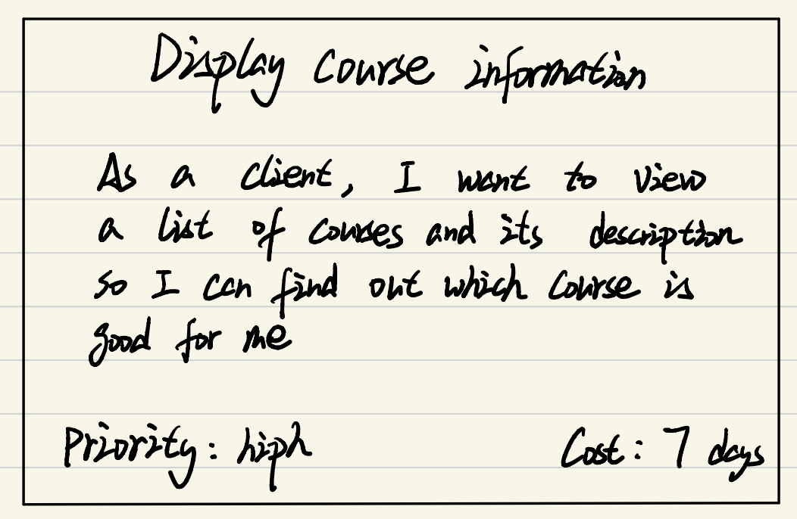

-small story1:Display course schedule

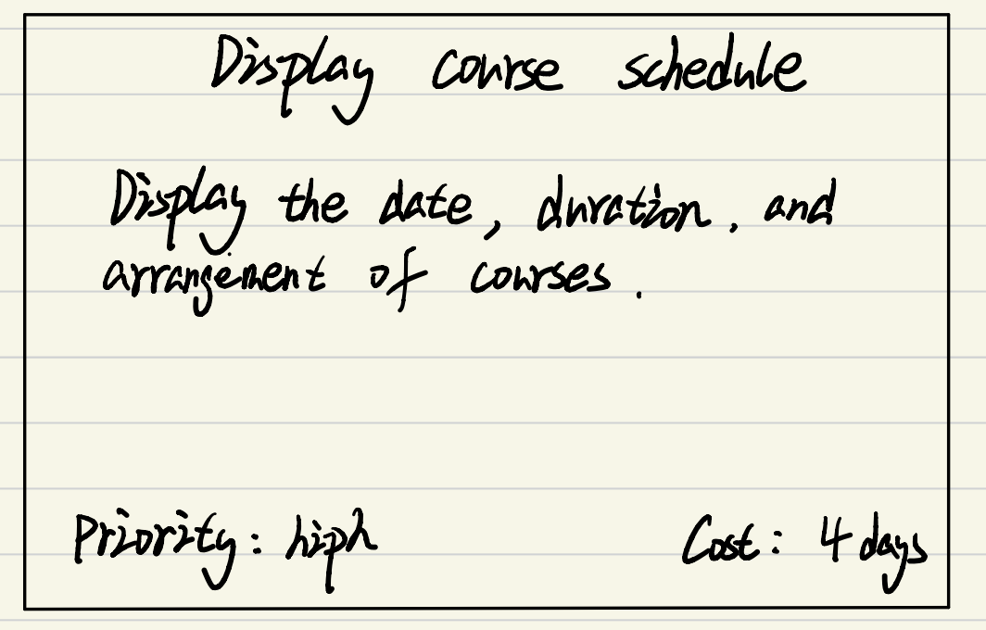

-small story2:Course price

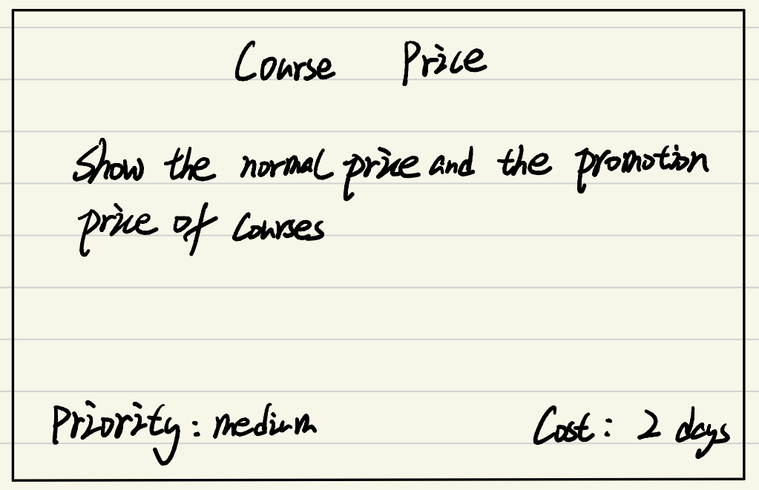

-small story3:Benefits of course

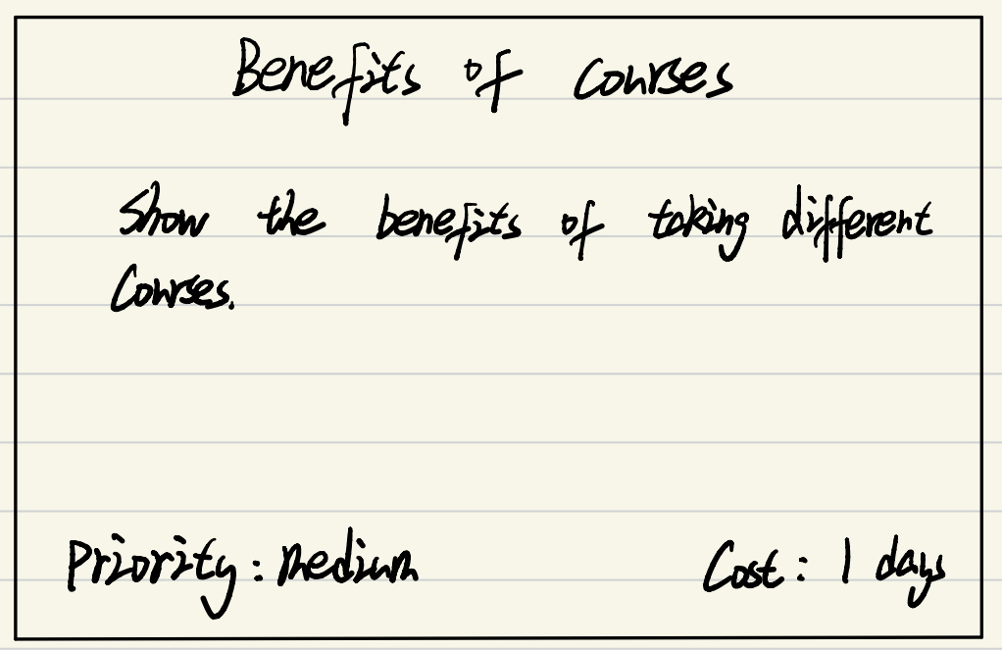

* + 1. big story 2:Personal training courses

-small story1:Information of coaches

-small story2:Meal plan

-small story3:Exercise plan

* + 1. big story 3:Course management

-small story1:Add course

-small story2:Delete course

-small story3:Transfer course

### category 2: membership and coach management

i. big story 1: Modify Membership

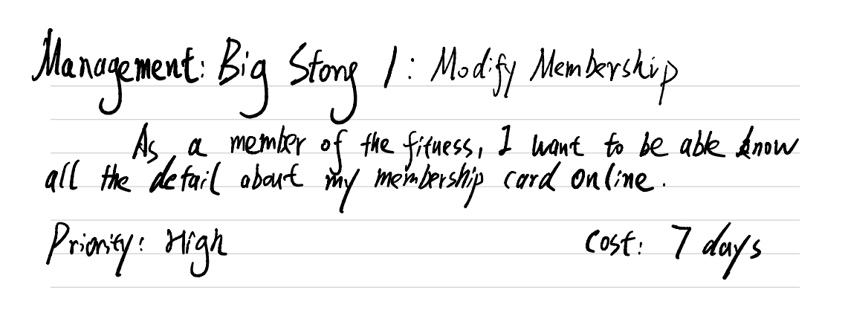

-small story 1: Display Membership Information

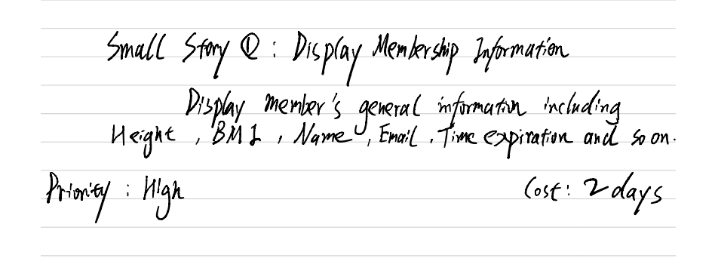

-small story 2: Determine Member’s Body’s Index

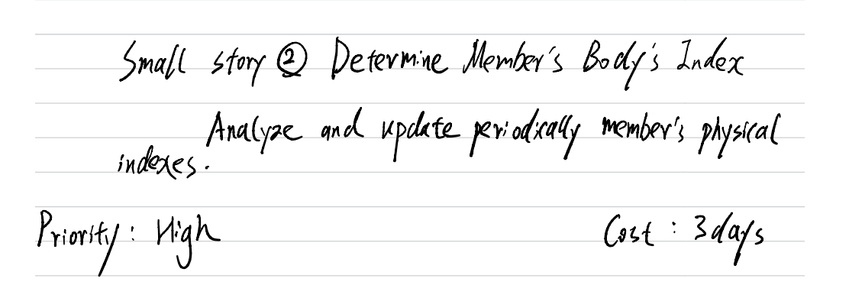

-small story 3: Register new Membership

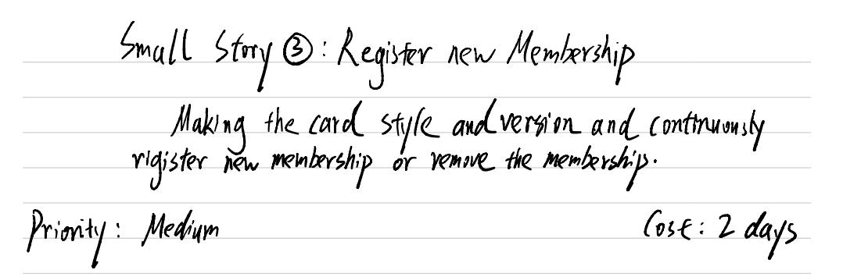

ii. big story 2: Modify Coaches

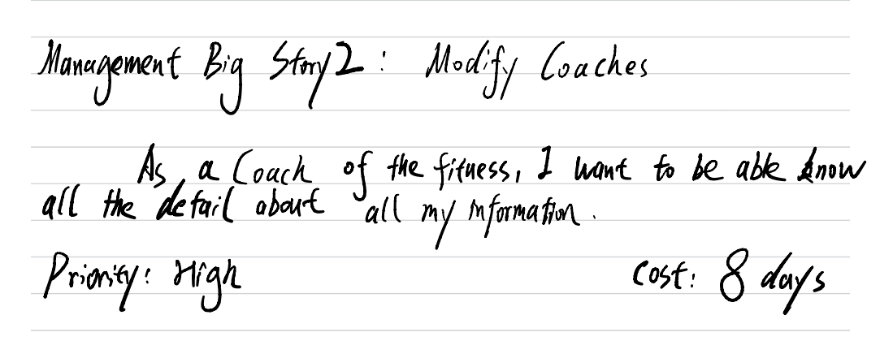

-small story 1: Display Coaches’ Information

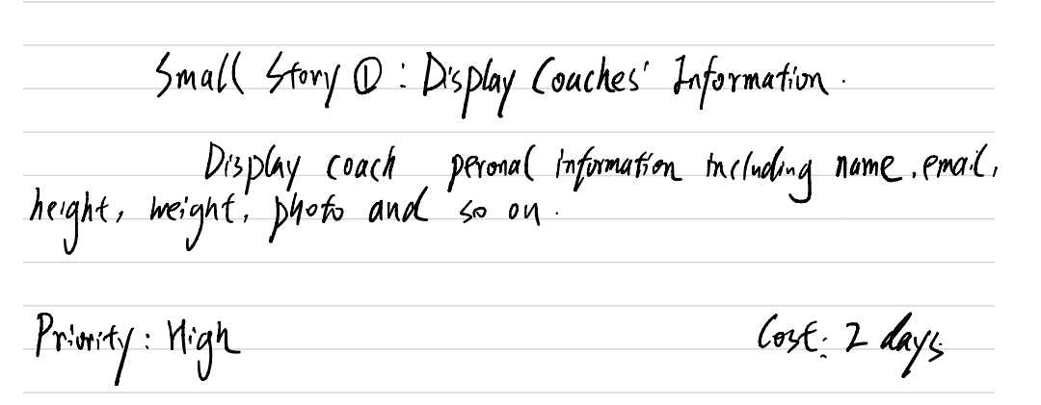

-small story 2: Determine Coaches’ Body Index

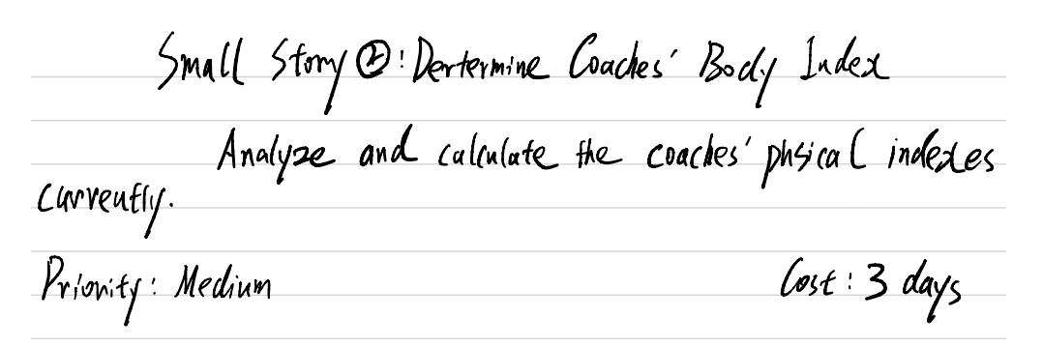

-small story 3: Display Coaches’ Working availability

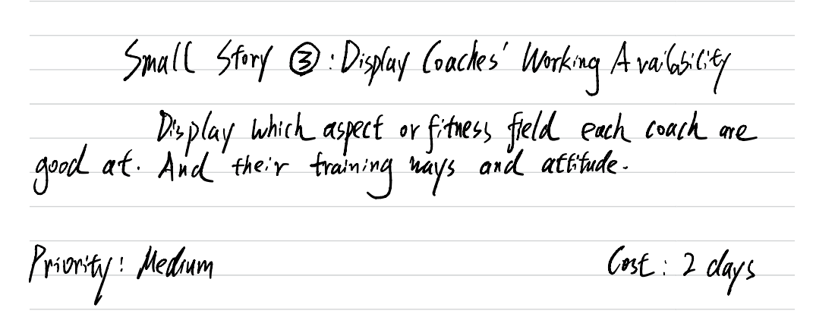

-small story 4: Register new Coaches

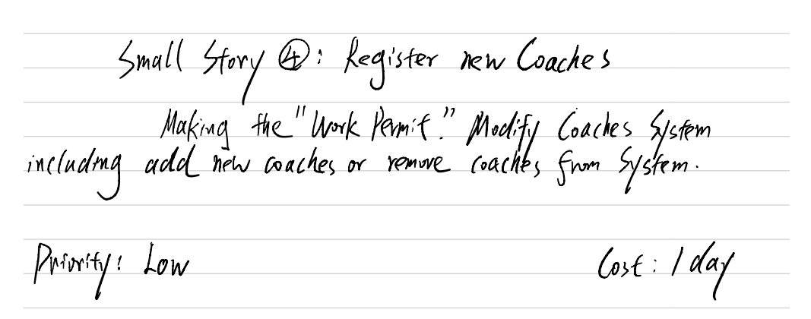

iii. big story 3: Modify managers

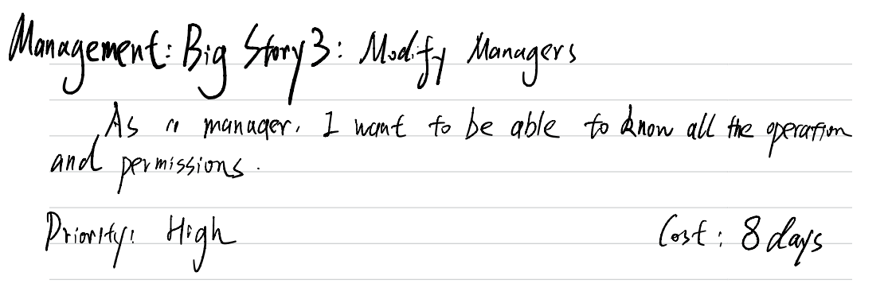

-small story 1: Remove members or coaches

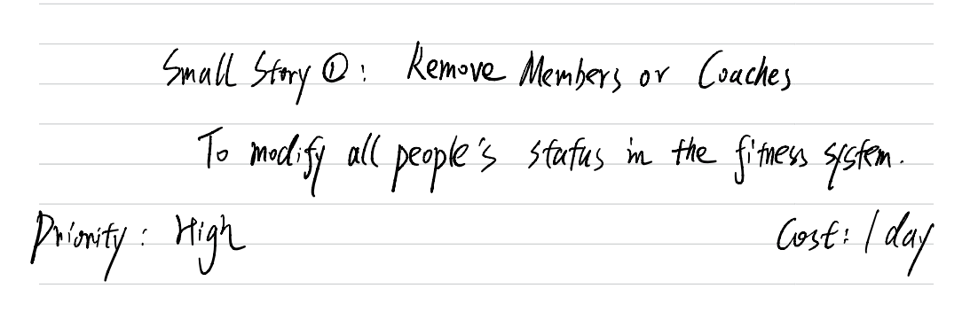

-small story 2: Display the work hours

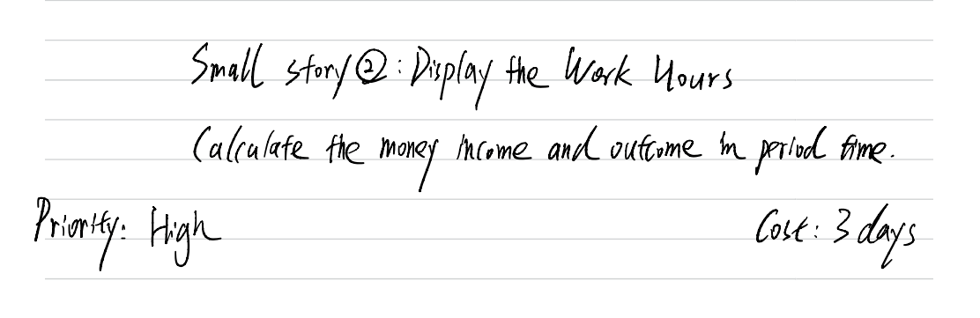

-small story 3: Pay the Staffs Salary

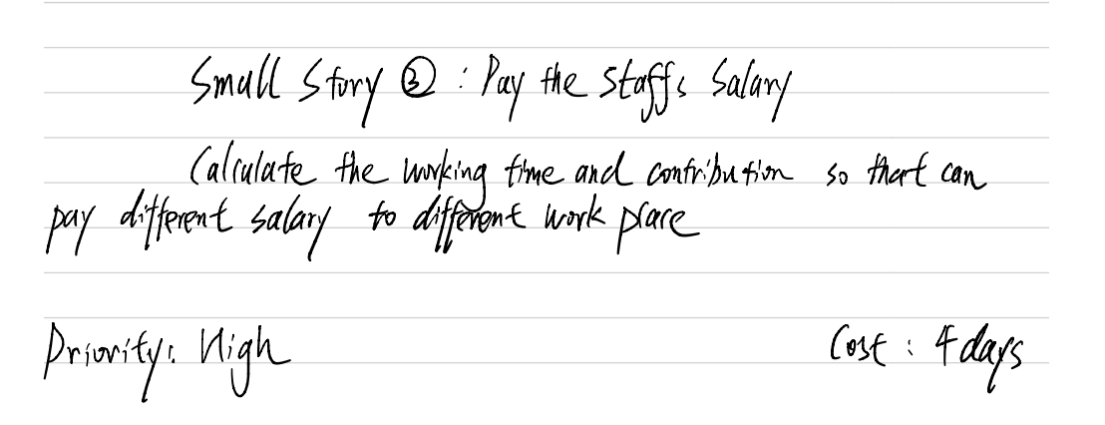

### category 3: facility management

* + 1. big story 1:Inventory

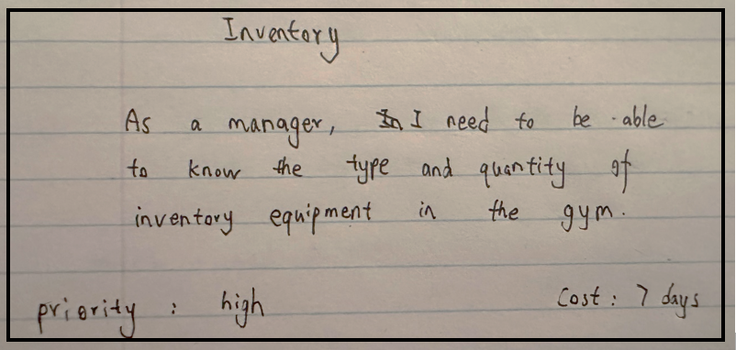

-small story1:Display Inventory

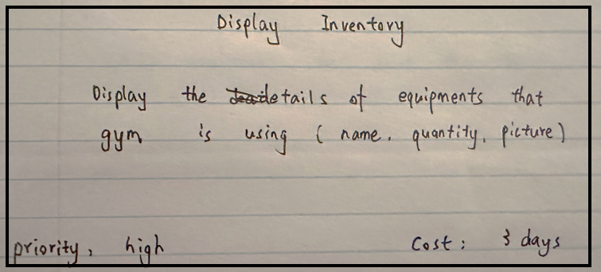

-small story2:Modify Inventory

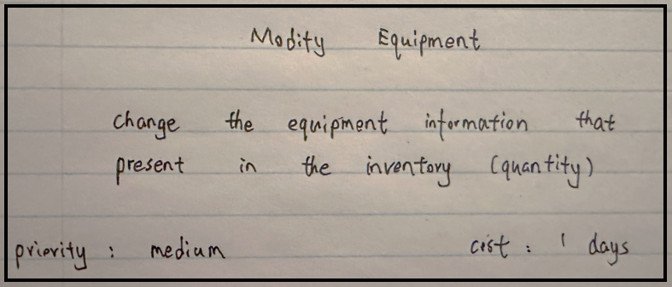

-small story3:Add equipment

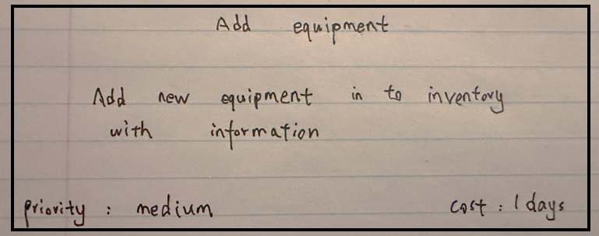

-small story4: Delete equipment

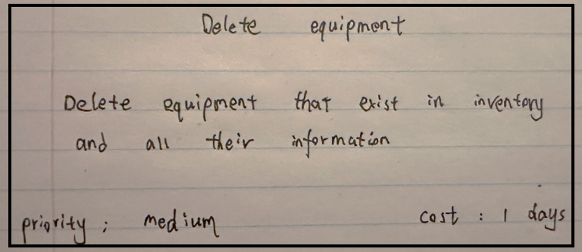

* + 1. big story 2:Equipment Information

-small story1:General Equipment description

-small story2:Display equipment information

-small story3:Equipment price

* + 1. big story 3:Equipment Management

-small story1:Display In-use equipment

-small story2:Customer Equipment Needs

-small story3:Damaged equipment